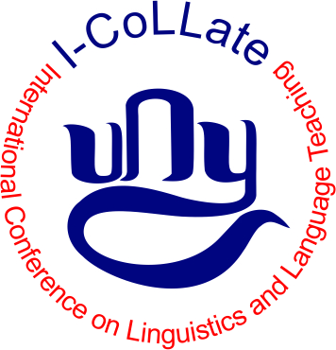

THE 2ND INTERNATIONAL CONFERENCE ON LINGUISTICS AND LANGUAGE TEACHING
ICOLLATE 2017 YOGYAKARTA STATE UNIVERSITY

FULL PAPER TEMPLATE

Title of Paper (Captitalize first letter)
[Times New Roman 14, bold, centered]
Author11 and Author22
[Times New Roman 11, bold, centered]
1,2 Author Affiliation
1e-mail of Author1 and 2e-mail of Author2
[Times New Roman 11, centered]

Abstract
[Times New Roman 12, bold]

Keywords: (6 words maximum)

INTRODUCTION [Times New Roman 12, bold]

Manuscript paper is single-spaced, written in two column format, on standard A4-sized paper (21 cm x 29.7 cm) with a maximum of 7 pages. Use 2.50 cm top and left margin, 2.50 cm bottom and right margin, and 2.50 cm for the header and footer.
Please do not place any page numbers, headers and footers in the manuscript.

LITERATURE REVIEW

RESEARCH METHOD (if any)

DISCUSSION

CONCLUSION/CLOSING REMARKS

REFERENCES

[1] G. Eason, B. Noble, and I.N. Sneddon, “On certain integrals of Lipschitz-Hankel type involving products of Bessel functions,” Phil. Trans. Roy. Soc. London, vol. A247, pp. 529-551, April 1955.

[2] J. Clerk Maxwell, A Treatise on Electricity and Magnetism, 3rd ed., vol. 2.Oxford: Clarendon, 1892, pp.68-73.

[3] I.S. Jacobs and C.P. Bean, “Fine particles, thin films and exchange anisotropy,” in Magnetism, vol. III, G.T. Rado and H. Suhl, Eds.New York: Academic,
1963, pp. 271-350.

[4] K. Elissa, “Title of paper if known,” unpublished.

[5] R. Nicole, “Title of paper with only first word capitalized,” J. Name Stand. Abbrev., in press.

(7 pages maximum)

THE 2ND INTERNATIONAL CONFERENCE ON LINGUISTICS AND LANGUAGE TEACHING
(ICOLLATE) 2017 YOGYAKARTA STATE UNIVERSITY

PRESENTATION TEMPLATE

1: Title
Name of Presenter
Institution
Email Address
2: Introduction
3: Research Question
4: Research Objectives
5: Scope of Research
6: Literature Review
7: Methodology (if any)
8: Discussion
9: Conclusion/Closing Remarks

Maximum : 15 slides
Duration of Presentation : 10 minutes
Q & A Session : 10 minutes

